Pizza Sales SQL queries

KPI

1.total revenue

select sum(total_price) as total_revenue from [pizza_sales excel file]

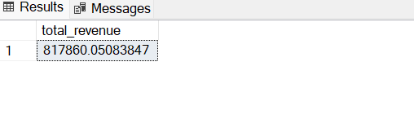

2.average order value

select sum(total_price) / COUNT(DISTINCT ORDER_ID) as average_order_value FROM [pizza_sales excel file]

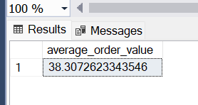

3. total pizza sold

select sum(quantity) as total_pizza_sold from [pizza_sales excel file]

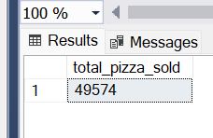

4.Total orders

select count( distinct order_id) as total_orders from [pizza_sales excel file]

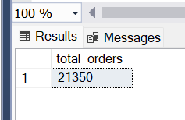

5.average pizzas per order

select cast(cast(sum(quantity) as decimal(10,2)) / cast(COUNT(distinct order_id)as decimal(10,2)) as decimal(10,2)) as avg_piza_per_order from [pizza_sales excel file]

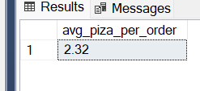

b.daily trend for total orders

select DATENAME(dw, order_date)as order_date, count(distinct order_id) as total_order from [pizza_sales excel file] group by DATENAME(dw, order_date)

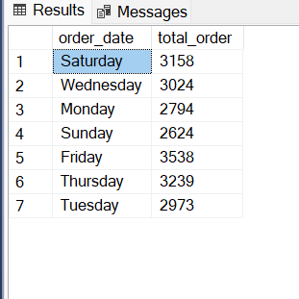

c.hourly Trend for total orders

select DATEPART(hour, order_time) as order_hour,count(distinct order_id) as total_order from [pizza_sales excel file] group by DATEPART(hour, order_time) order by DATEPART(hour, order_time)

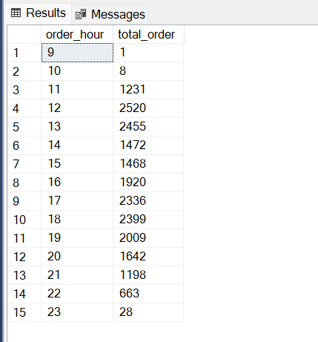

d.percentage of sales by pizza category

(if you want to get the month wise data you need to apply where clause )

select pizza_category, cast(sum(total_price)as decimal(10,2)) as total_sales,CAST(sum(total_price)*100/

(select sum(total_price) from [pizza_sales excel file]) AS DECIMAL(10,2)) AS PCT

from [pizza_sales excel file] group by pizza_category

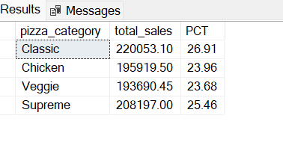

e.PERCENTAGE OF SALES BY PIZZA SIZE

select pizza_size, cast(sum(total_price)as decimal(10,2)) as total_sales, cast(sum(total_price)*100/(select sum(total_price)

from [pizza_sales excel file] where DATEPART(QUARTER, order_date)=1) as decimal(10,2)) as pct

from [pizza_sales excel file] where DATEPART(QUARTER, order_date)=1 group by pizza_size

order by pct desc

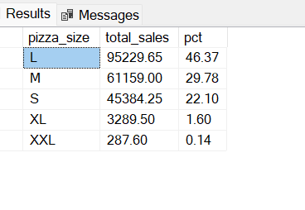

f. total pizza sold by pizza category

SELECT PIZZA_CATEGORY, SUM(quantity) AS TOTAL_SALES FROM [pizza_sales excel file] GROUP BY pizza_category ORDER BY SUM(quantity) DESC

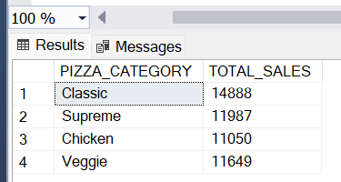

g. top 5 best sellers by total pizzas sold

select top 5 pizza_name, sum(quantity) as total_sales from [pizza_sales excel file]

group by pizza_name order by sum(quantity) desc

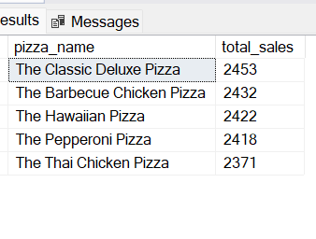

h. bottom 5 sellers by total pizzas sold

select top 5 pizza_name, sum(quantity) as total_sales from [pizza_sales excel file]

group by pizza_name order by sum(quantity) asc

